Table of Contents

Group Profile 2

Question1: Use the open-source NLP 3

Task 1: Extract the ‘text’ in all the CSV files and store into a single ‘.txt file’ 3

Task 2: Research 4

Task 3: Programming and Research 6

Task 4: Named-Entity Recognition (NER) 11

Question 2 18

Chapter 1: The Gatekeeper 18

Chapter 2: The Chamber of Strings 21

First program: 21

Second program: 22

Question 3 23

1. Fixing the next code will reveal the key. 23

2. Write the decryption function to decrypt the ‘encrypted code’ to the original code. 24

3. Correct the errors and provide the comments 26

Question 4 28

# 

# Group Profile

**Group Members:**  
[Sameer Basnet] - [S372941]  
[Samir Dhakal] - [S373048]  
[Susanti Djie] - [S375655]  
[Nishat Anjum] - [S374044]

**Github:**

<https://github.com/Sameer84/HIT137-Assignment-02.git>

# Question1: Use the open-source NLP

## Task 1: Extract the ‘text’ in all the CSV files and store into a single ‘.txt file’

**Programming code:**

# 1-1 Extract file

# Extract the ‘text’ in all the CSV files

# and store them into a single ‘.txt file’.

try:

# put csv file names to list

csv_files = ['./q1/CSV1.csv', './q1/CSV2.csv', './q1/CSV3.csv', './q1/CSV4.csv']

with open('./q1/merged_csv.txt', 'w') as f_out:

# open each csv

for file in csv_files:

with open(file, 'r') as f_in:

content = f_in.read()

f_out.write(content)

print()

print('proccess done.')

except IOError as e:

# if any csv file is missing

print('IOError : ', e.errno, e)

finally:

print('clean up...')

f_in.close()

f_out.close()

**#Output**

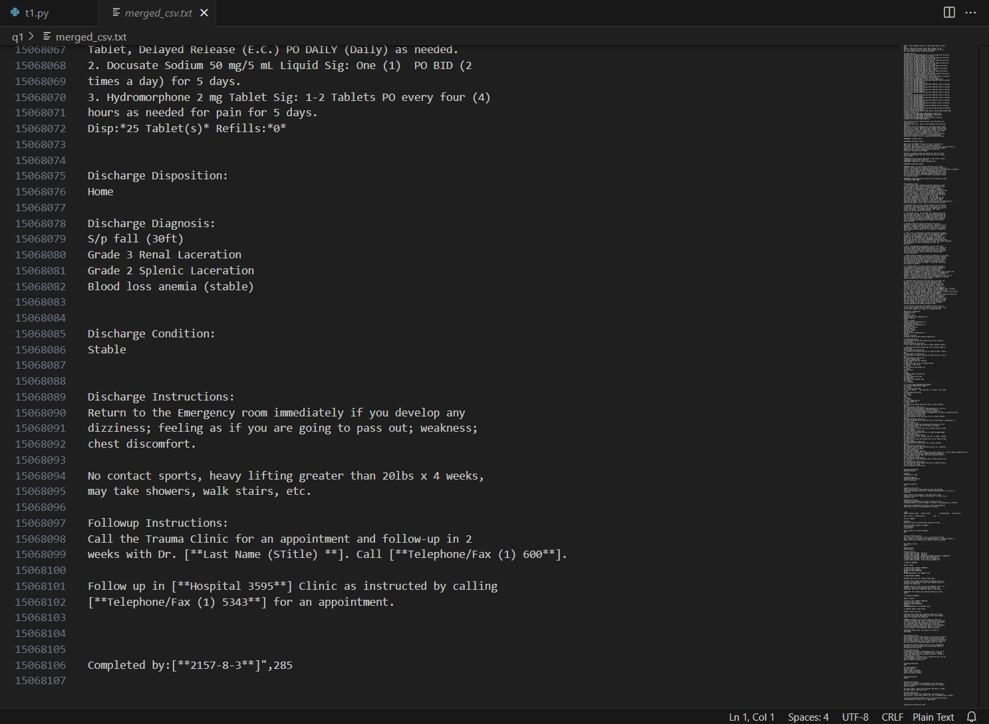

## Task 2: Research

**Programming code:**

# requirements.txt

pandas

numpy

torch

# spacy and en_core_web_sm model

spacy==3.6.1

# !!important: scispacy only works with python 3.8 or below with nmslib

# check: <https://github.com/allenai/scispacy/issues/291>

# scispacy and en_ner_bc5cdr_md model

scispacy==0.5.3

<https://s3-us-west-2.amazonaws.com/ai2-s2-scispacy/releases/v0.5.3/en_core_sci_sm-0.5.3.tar.gz>

<https://s3-us-west-2.amazonaws.com/ai2-s2-scispacy/releases/v0.5.3/en_ner_bc5cdr_md-0.5.3.tar.gz>

# transformers

transformers

**#Output**

pip install -r .\requirements.txt

## Task 3: Programming and Research

**Programming code:**

import os

import shutil

import csv

from itertools import islice

from collections import Counter

from transformers import AutoTokenizer

NUM_OF_LINES = 100000

WORKER_POOL_SIZE = 2

PRE_DIR_NAME = './q1'

INPUT_FILE = PRE_DIR_NAME + '/merged_csv.txt'

CHUNKS_DIRECTORY = PRE_DIR_NAME + '/chunks'

def delete_dir_if_exists(dir_name):

if os.path.exists(dir_name):

shutil.rmtree(dir_name)

def create_dir_if_not_exists(dir_name):

if not os.path.exists(dir_name):

os.makedirs(dir_name)

def slice_huge_file():

cnt = 0

with open(INPUT_FILE) as f:

while True:

next_n_lines = list(islice(f, NUM_OF_LINES))

cnt += 1

if not next_n_lines:

break

with open(CHUNKS_DIRECTORY + '/sub_huge_{}.txt'.format(cnt), 'w') as out:

out.writelines(next_n_lines)

def count_file_words(input_file):

count_from_at = count_and_top_words(input_file, "dmis-lab/biobert-v1.1")

with open(input_file, 'r') as f:

lines = [line.strip() for line in f.readlines() if line.strip()]

count_from_bl = Counter(lines)

return count_from_bl, count_from_at

def count_unique_tokens(file_path):

tokenizer = AutoTokenizer.from_pretrained("dmis-lab/biobert-v1.1")

# Read the text file

with open(file_path, 'r') as file:

text = file.read()

# Tokenize the text

tokens = tokenizer.tokenize(text)

# Count the unique tokens

token_counts = Counter(tokens)

# Get the top 30 words

top_30_words = token_counts.most_common(30)

return top_30_words

def count_and_top_words(input_file, model_name, chunk_size=750):

# Load the AutoTokenizer

tokenizer = AutoTokenizer.from_pretrained(model_name)

# Initialize an empty counter for token counts

token_counts = Counter()

# Read the text from the file in chunks

with open(input_file, 'r', encoding='utf-8') as file:

while True:

chunk = file.read(chunk_size)

if not chunk:

break

# Tokenize the chunk and update token counts

tokens = tokenizer.tokenize(tokenizer.decode(tokenizer.encode(chunk)))

token_counts.update(tokens)

return token_counts

def export_to_file(file_path, most_common_30):

if os.path.exists(file_path):

os.remove(file_path)

with open(file_path, 'w', newline='') as file:

writer = csv.writer(file)

writer.writerow(['Word', 'Count'])

writer.writerows(most_common_30)

file.close()

if __name__ == '__main__':

delete_dir_if_exists(CHUNKS_DIRECTORY)

create_dir_if_not_exists(CHUNKS_DIRECTORY)

slice_huge_file()

sub_files = [os.path.join(CHUNKS_DIRECTORY, f) for f in os.listdir(CHUNKS_DIRECTORY) if f.startswith('sub_huge')]

# results from built in library

results_bl = Counter()

# results from Auto Tokenizer

results_at = Counter()

for sub_file in sub_files:

count_from_bl, count_from_at = count_file_words(sub_file)

results_bl += count_from_bl

results_at += count_from_at

most_common30_bl = results_bl.most_common(30)

most_common30_at = results_at.most_common(30)

# Export most common 30 words from built in library to CSV

export_to_file(PRE_DIR_NAME + '/most_common_30_builtInLibrary.csv', most_common30_bl)

# Export most common 30 words from Auto Tokenizer to txt

export_to_file(PRE_DIR_NAME + '/most_common_30_AutoTokenizer.txt', most_common30_at)

# clean up

results_bl.clear()

results_at.clear()

**#Output**

Using any in-built library present in Python, count the occurrences of the words in the text (.txt) and give the ‘Top 30’ most common words. And store the ‘Top 30’ common words and their counts into a CSV file.

most_common_30_builtInLibrary.csv

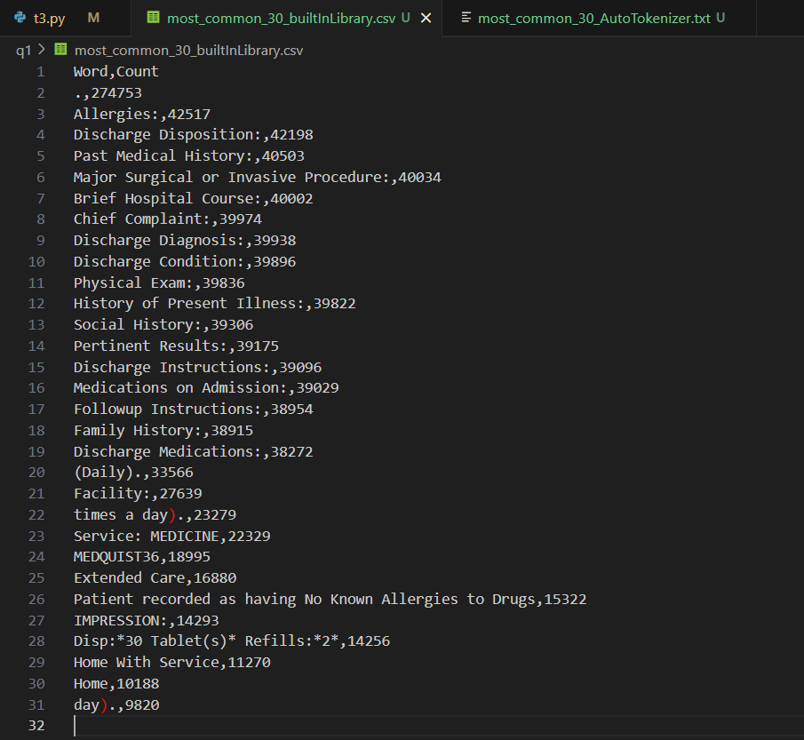

Using the ‘Auto Tokenizer’ function in the ‘Transformers’ library, write a ‘function’ to count unique tokens in the text (.txt) and give the ‘Top 30’ words.

most_common_30_AutoTokenizer.txt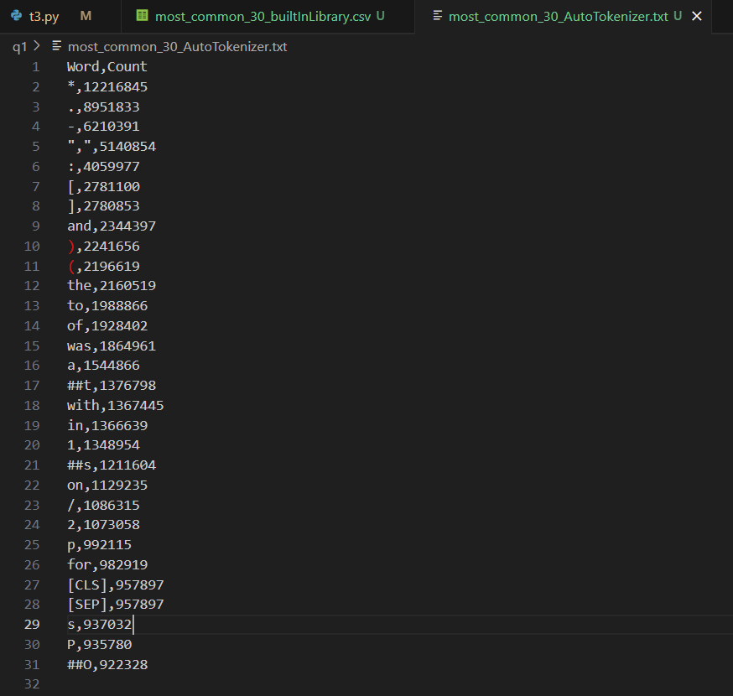

## Task 4: Named-Entity Recognition (NER)

Extract the ‘diseases’, and ‘drugs’ entities in the ‘.txt file’ separately using ‘en_core_sci_sm’/’en_ner_bc5cdr_md’ and biobert. And compare the differences between the two models (Example: Total entities detected by both of them, what’s the difference, check for most common words, and check the difference.)

**Programming code:**

import os

from collections import Counter

import spacy, scispacy

from transformers import AutoTokenizer, AutoModelForTokenClassification, pipeline

PRE_DIR_NAME = './q1'

INPUT_FILE = PRE_DIR_NAME + '/merged_csv.txt'

OUTPUT_DIR = PRE_DIR_NAME + '/results'

MODEL_NAME = 'dmis-lab/biobert-v1.1'

def count_and_top_words(doc, chunk_size=900000, top_n=30):

entities = [ent.text for ent in doc.ents]

total_entities = len(entities)

# Extract 'diseases' entities

diseases_ent = [ent.text for ent in doc.ents if ent.label_ == 'DISEASE']

# Extract 'drugs' entities

drugs_ent = [ent.text for ent in doc.ents if ent.label_ == 'DRUG']

# Extract entities length

extract_entities = len(diseases_ent) + len(drugs_ent)

# Tokenize the chunk and update token counts

top_tokens = Counter(entities)

return entities, total_entities, diseases_ent, drugs_ent, extract_entities, top_tokens

def run():

if not os.path.exists(OUTPUT_DIR):

os.makedirs(OUTPUT_DIR)

# Load the 'en_core_sci_sm' model

en_core_sci_sm = "en_core_sci_sm"

nlp_sci_sm = spacy.load(en_core_sci_sm)

entities_sci_sm = []

total_entities_sci_sm = 0

diseases_model_sci_sm = []

drugs_model_sci_sm = []

tokens_sci_sm = Counter()

# Load the 'en_ner_bc5cdr_md' model

en_ner_bc5cdr_md = "en_ner_bc5cdr_md"

nlp_bc5cdr_md = spacy.load(en_ner_bc5cdr_md)

entities_bc5cdr_md = []

total_entities_bc5cdr_md = 0

diseases_model_bc5cdr_md = []

drugs_model_bc5cdr_md = []

tokens_bc5cdr_md = Counter()

# Load the NER pipeline with biobert model

tokenizer = AutoTokenizer.from_pretrained(MODEL_NAME)

model = AutoModelForTokenClassification.from_pretrained(MODEL_NAME)

# Extract entities using the NER pipeline

nlp = pipeline("ner", model=model, tokenizer=tokenizer)

# Load the 'en_core_sci_sm' model

entities_biobert = []

total_biobert = 0

filtered_biobert = []

tokens_biobert = Counter()

with open(OUTPUT_DIR + '/t4_result.txt', 'w') as f_out:

with open(INPUT_FILE, 'r', encoding='utf-8') as file:

# Read the text from the file in chunks

chunk_size = 900000

while True:

chunk = file.read(chunk_size)

if not chunk:

break

entities, total_entities, diseases_ent, drugs_ent, extract_entities, top_tokens = \

count_and_top_words(nlp_sci_sm(chunk), chunk_size=chunk_size)

entities_sci_sm += entities

total_entities_sci_sm += total_entities

diseases_model_sci_sm += diseases_ent

drugs_model_sci_sm += drugs_ent

tokens_sci_sm += top_tokens

entities, total_entities, diseases_ent, drugs_ent, extract_entities, top_tokens = \

count_and_top_words(nlp_bc5cdr_md(chunk), chunk_size=chunk_size)

entities_bc5cdr_md += entities

total_entities_bc5cdr_md += total_entities

diseases_model_bc5cdr_md += diseases_ent

drugs_model_bc5cdr_md += drugs_ent

tokens_bc5cdr_md += top_tokens

print(f'Total entities detected {en_core_sci_sm}: {total_entities_sci_sm}')

print(f'Total entities detected {en_ner_bc5cdr_md}: {total_entities_bc5cdr_md}')

f_out.write(f'Total entities detected {en_core_sci_sm}: {total_entities_sci_sm}')

f_out.write(f'Total entities detected {en_ner_bc5cdr_md}: {total_entities_bc5cdr_md}')

f_out.write(f'Top 30 entities {en_core_sci_sm}: {len(tokens_bc5cdr_md.most_common(30))}')

f_out.write(f'Top 30 entities {en_ner_bc5cdr_md}: {len(tokens_sci_sm.most_common(30))}')

f_out.write(f'Total extracted entities {en_core_sci_sm}: {len(diseases_model_sci_sm) + len(drugs_model_sci_sm)}')

f_out.write(f'Total extracted entities {en_ner_bc5cdr_md}: {len(diseases_model_bc5cdr_md) + len(drugs_model_bc5cdr_md)}')

f_out.write(f'All entities {en_core_sci_sm}: {entities_sci_sm}')

f_out.write(f'All entities {en_ner_bc5cdr_md}: {entities_bc5cdr_md}')

# Read the text from the file in chunks

chunk_size = 700

while True:

chunk = file.read(chunk_size)

if not chunk:

break

doc_biobert = nlp(chunk)

entities_biobert += [entity['word'] for entity in doc_biobert]

filtered_biobert = [entity['word'] for entity in doc_biobert if entity['entity'] == 'DRUG' or entity['entity'] == 'DISEASE']

total_biobert += len(entities_biobert)

tokens_biobert += Counter(filtered_biobert)

print(f'Total entities detected {MODEL_NAME}: {total_biobert}')

f_out.write(f'Total entities detected {MODEL_NAME}: {total_biobert}')

f_out.write(f'Top 30 entities {MODEL_NAME}: {tokens_biobert.most_common(30)}')

f_out.write(f'Total extracted entities {MODEL_NAME}: {len(filtered_biobert)}')

f_out.write(f'All entities {MODEL_NAME}: {entities_biobert}')

file.close()

f_out.close()

run()

**#Output**

what’s the difference:

'en_ner_bc5cdr_md' can label entities with diseases, drugs, and other symptoms, but the other two models only label as 'ENTITY'. So, if a user wants to filter words, they need to prepare a list of labels (e.g., dyslipidemia, hypertension as symptoms) and add logic to extract the requirements.

Also, BioBERT with Transformers can only handle a token count of 512 compared to a text length of 1,000,000 for NER models and the parser. Therefore, it is advisable to use a fine-tuned model to process faster and more efficiently.

Most common 30 words with BioBERT.txt

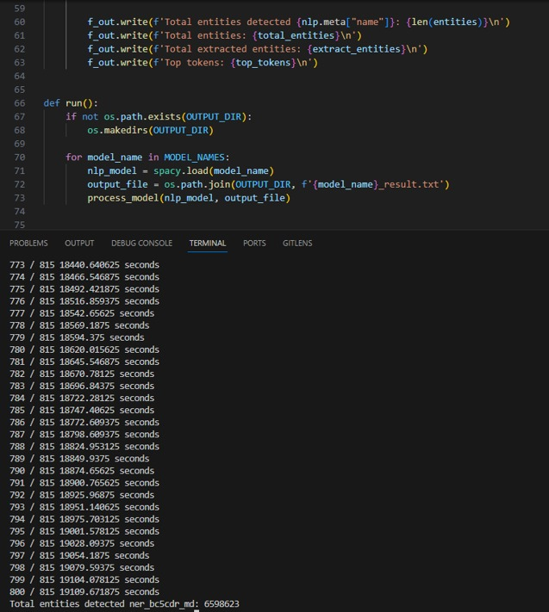

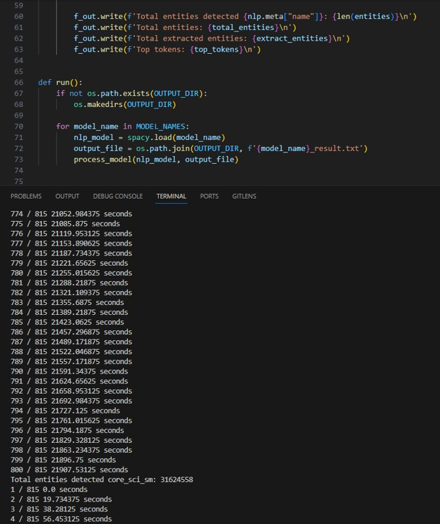

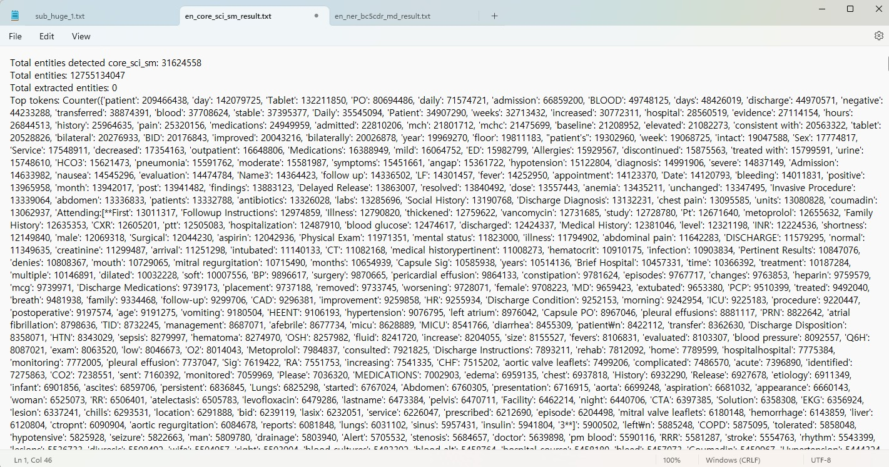

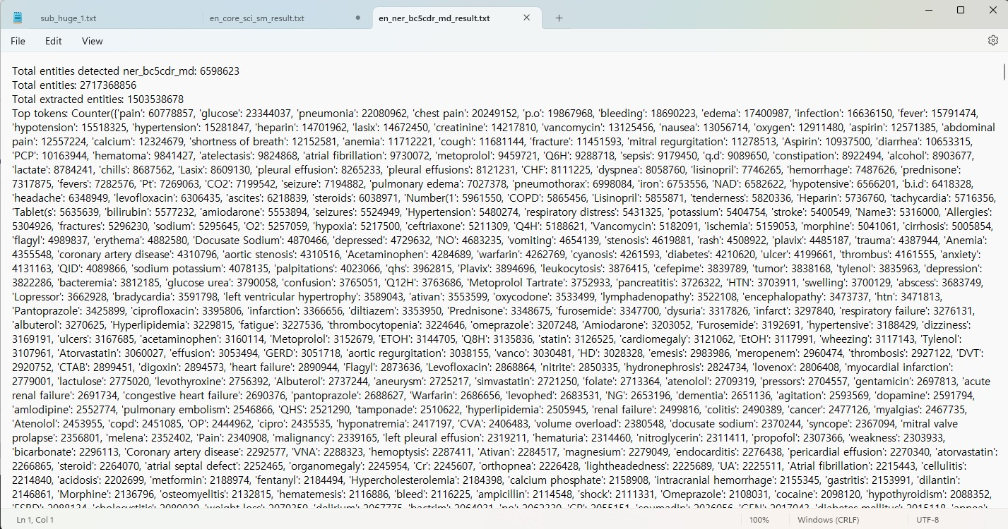

# Question 2

## Chapter 1: The Gatekeeper

**Programming code:**



Figure 1: chapter1.jpg

import os, sys

from PIL import Image

import time

#Open the original picture.

image_direction = "chapter1.jpg"

provided_image = Image.open(image_direction)

#Produce the figure

live_time = int(time.time())

produced_number = (live_time % 100) + 50

if produced_number % 2 == 0:

    produced_number += 10

#Make a fresh image that is identical to the first in terms of size and mode

new_image = Image.new("RGB", provided_image.size)

#Get each image's pixel data.

initial_pixels = provided_image.load()

new_pixels = new_image.load()

#Iterate through every pixel, make changes, and figure out how much each red pixel is worth.

red_sum = 0

width, height = provided_image.size

for i in range(width):

    for j in range(height):

        r, g, b = initial_pixels[i, j]

        altered_pixel = (r + produced_number, g + produced_number, b + produced_number)

        new_pixels[i, j] = altered_pixel

        red_sum += altered_pixel[0]  #Build up your red values.

#Save the updated picture.

output_image_path = "chapter1out.jpg"

new_image.save(output_image_path)

#Show a notification that the procedure is finished.

print(f"Updated picture with changed pixels saved as {output_image_path}")

print(f"Total red pixel values in the updated picture: {red_sum}")

**#Output**

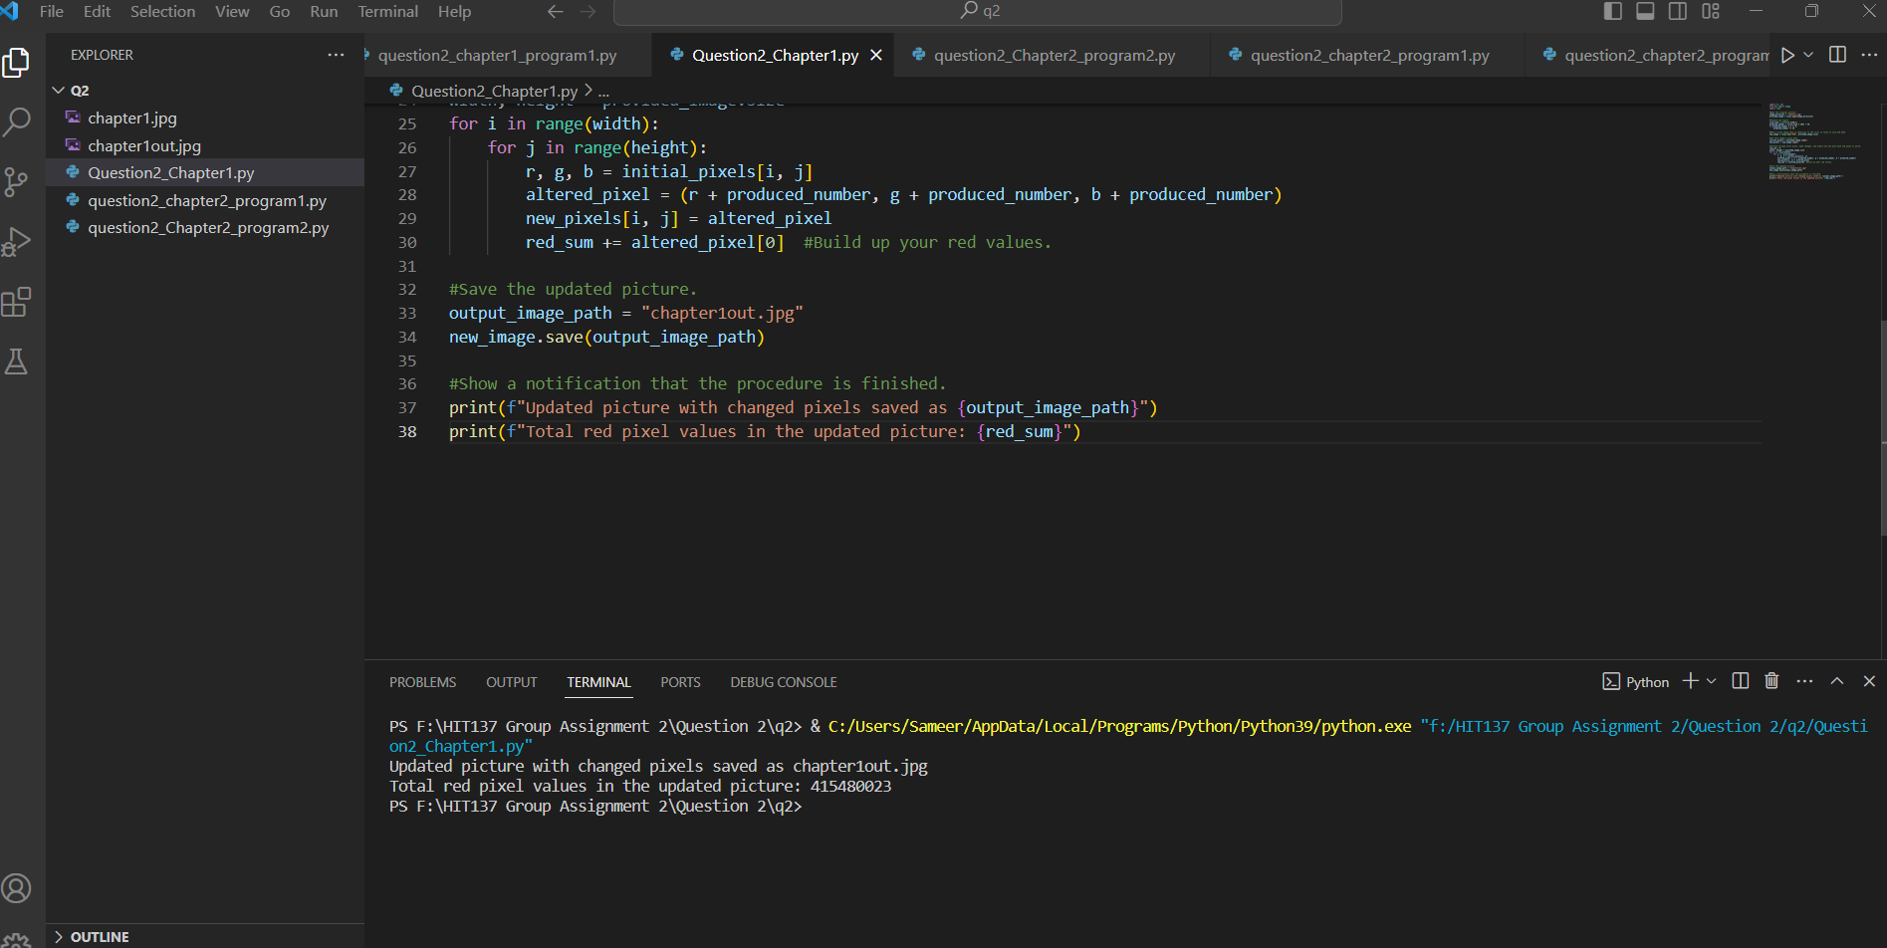

Figure 2: Output of Question2_Chapter1.py



Figure 3: chapter1out.jpg

## Chapter 2: The Chamber of Strings

### First program:

**Programming code:**

def divide_and_seperate(a):

    number_string = ''

    letter_string = ''

    for char in a:

        if char.isdigit():

            number_string += char

        elif char.isalpha():

            letter_string += char

    #ASCII values of characters if digit is even

    even_numbers_ascii = [str(ord(char)) for char in number_string if int(char) % 2 == 0]

    #contain the ASCII values of the uppercase letters

    upper_case_ascii = [str(ord(char)) for char in letter_string if char.isupper()]

    return number_string, letter_string, even_numbers_ascii, upper_case_ascii

#example from question

input_question_string = '56aAw1984sktr235270aYmn145ss785fsq3100'

#calling divide_and_seperate function

result = divide_and_seperate(input_question_string)

number_string, letter_string, even_numbers_ascii, upper_case_ascii = result

print(f'Seperate Number String: {number_string}')

print(f'Seperate Letter String: {letter_string}')

print(f'Even Numbers to ASCII Code: {", ".join(even_numbers_ascii)}')

print(f'Upper-case Letters to ASCII Code: {", ".join(upper_case_ascii)}')

**Output:**

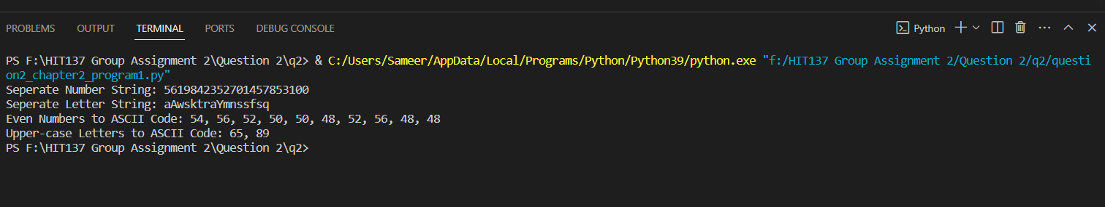

Figure 4: Output of question2_chapter2_program1.py

### Second program:

**Programming code:**

def decrypt(cryptogram, shift):

    decrypted_text = ""

    for char in cryptogram:

        if char.isalpha():

            if char.isupper():

                decrypted_text += chr((ord(char) - shift - 65) % 26 + 65)

            else:

                decrypted_text += chr((ord(char) - shift - 97) % 26 + 97)

        else:

            decrypted_text += char

    return decrypted_text

def find_shift_key(cryptogram):

    for shift in range(1, 26):

        decrypted_text = decrypt(cryptogram, shift)

        print(f"Shift Key: {shift}, Decrypted Text: {decrypted_text}")

# Provided cryptogram

cryptogram = "VZ FRYSVFU VZCNGVIRAG NAQ N YUGGYR VAFRPHEIR V ZNXR ZVEGNXRF V NZ BHG US PRAGEBY NAQNG GVZRE UNEQ GB UNAQYIR OHG VS LBH PNAG UNAQYR ZR NG ZL JBEFG GURA LOH HER N URYYQBAG URFREIR ZR NG ZL ORFG ZNEVYLA ZEAEBR"

# Find the shift key(s)

find_shift_key(cryptogram)

**Output:**

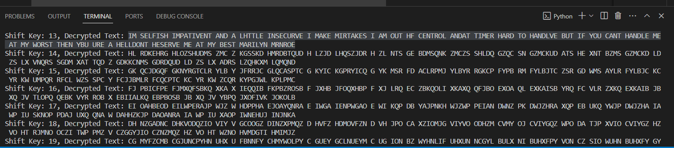

Figure 5: Output of question2_Chapter2_program2.py

# Question 3

## 1. Fixing the next code will reveal the key.

**Programming code:**

total = 0

for i in range(5):

    for j in range(3):

        if i + j == 5:

            total += i + j

        else:

            total -= i - j

counter = 0

while counter < 5:

    if total < 13:

        total += 1

    elif total > 13:

        total = 1

    else:

        counter += 2

print("Final Total:", total)

**Output:**

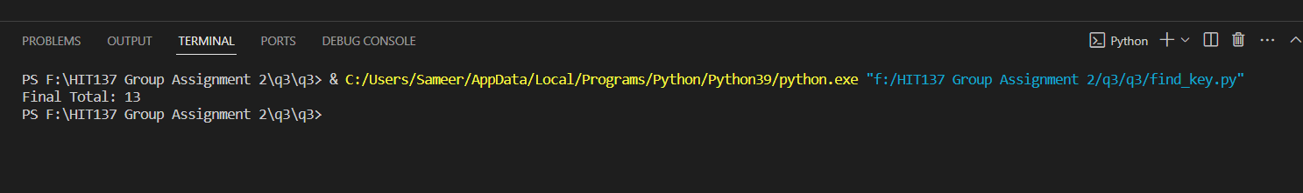

Figure 6:Output of find_key.py

## 2. Write the decryption function to decrypt the ‘encrypted code’ to the original code.

**Programming code:**

#This is encrypt function which takes a plaintext and a key

def encrypt(text, key):

    encrypted_text = ""

    for char in text: #Iterates over each character

        if char.isalpha():#If character is alphabetic

            shifted = ord(char) + key#calculates the shifted value by adding the key to the ASCII value of the character

            if char.islower():#if character is lowercase

                #if the character is beyond the lowercase range('a' to 'z')

                if shifted > ord('z'):

                    shifted -= 26

                elif shifted < ord('a'):

                    shifted += 26

            #If the character is uppercase

            elif char.isupper():

                if shifted > ord('Z'):

                    shifted -= 26

                elif shifted < ord('A'):

                    shifted += 26

            encrypted_text += chr(shifted)

        else:

            # non-alphabetic characters unchanged

            encrypted_text += char

    return encrypted_text

#Function to decrypt an encrypted text

def decrypt(encrypted_code, key):

    return encrypt(encrypted_code, -key)

#key value result from find_key.py program

key = 13

#Encrypted code

encrypted_code = """

tybony_inevnoyr = 100

zl_qvpg = {'xrl1': 'inyhr1', 'xrl2': 'inyhr2', 'xrl3': 'inyhr3'}

qrs cebprff_ahzoref():

    tybony tybony_inevnoyr

    ybpny_inevnoyr = 5

    ahzoref = [1, 2, 3, 4, 5]

    juvyr ybpny_inevnoyr > 0:

        vs ybpny_inevnoyr % 2 == 0:

            ahzoref.erzbir(ybpny_inevnoyr)

        ybpny_inevnoyr -= 1

    erghea ahzoref

zl_frg = {1, 2, 3, 4, 5, 5, 4, 3, 2, 1}

erfhyg = cebprff_ahzoref(ahzoref=zl_frg)

qrs zbqvsl_qvpg():

    ybpny_inevnoyr = 10

    zl_qvpg['xrl4'] = ybpny_inevnoyr

zbqvsl_qvpg(5)

qrs hcongr_tybony():

    tybony tybony_inevnoyr

    tybony_inevnoyr += 10

sbe v va enatr(5):

    cevag(v)

    v += 1

vs zl_frg vf abg Abar naq zl_qvpg['xrl4'] == 10:

    cevag("Pbaqvgvba zrg!")

vs 5 abg va zl_qvpg:

    cevag("5 abg sbhaq va gur qvpgvbanel!")

cevag(tybony_inevnoyr)

cevag(zl_qvpg)

cevag(zl_frg)

"""

# call decrypt function with value of encrypted_code and key

decrypted_code = decrypt(encrypted_code, key)

# Result of decrypted code

print(decrypted_code)

**Output:**

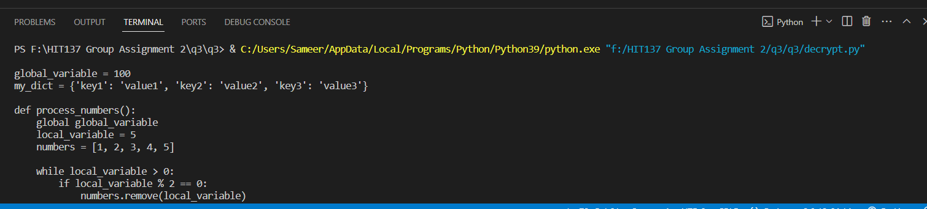

Figure 7: Output of decrypt.py

## 3. Correct the errors and provide the comments

**Programming Code:**

global_variable = 100 #global_variable is set to 100

my_dict = {'key1': 'value1', 'key2': 'value2', 'key3': 'value3'} # my_dic is initialized with some key-values

def process_numbers(numbers): #function process_numbers take parameter of numbers

    global global_variable

    local_variable = 5

    numbers = [1, 2, 3, 4, 5] #local variable numbers is initialized to [,2,3,4,5]

    while local_variable > 0: #while loop is used to iterate local varible is greater than 0

        if local_variable % 2 == 0: #if it is even numbers

            numbers.remove(local_variable) #removes number from list

        local_variable -= 1

    return numbers #returns modified numbers

my_set = {1, 2, 3, 4, 5, 5, 4, 3, 2, 1} #my_set is inialized

result = process_numbers(numbers=my_set)

def modify_dict(local_variable ): # function modify_dict takes parameter local_variable

    my_dict['key4'] = local_variable #Adds a new key to my_dict whith the value of local_variable

modify_dict(10)

def upbate_global():

    global global_variable

    global_variable += 10 #increaments by 10

for i in range(5):#Iterates over the range 0 to 4

    print(i)

    i += 1

if my_set is not None and my_dict['key4'] == 10:

    print("Condition met!")

if 5 not in my_dict:

    print("5 not found in the dictionary!")

print(global_variable) #print value of global_variable

print(my_dict)#print value of my_dict

print(my_set)#print value of my_set

**Output:**

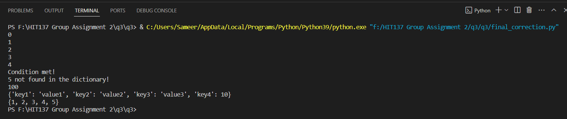

# Question 4

Welcome to the final task of this assignment. You are required to create a GitHub repository and add all your group mates to it (make sure to keep it public, not private). You should do this before you start the assignment. All the answers and contributions should be recorded in GitHub till you submit the assignment

**Output:**

<https://github.com/Sameer84/HIT137-Assignment-02.git>

**Group Members- Github profile**  
[Sameer Basnet] - [Sameer84]  
[Samir Dhakal] - [srd199]  
[Susanti Djie] - [SusantiDj]  
[Nishat Anjum] - [Nishat199]

